# Best Approach:

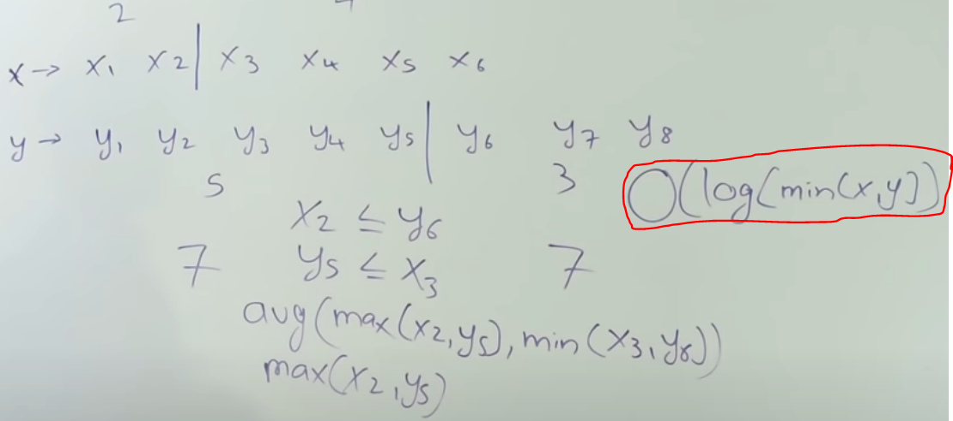

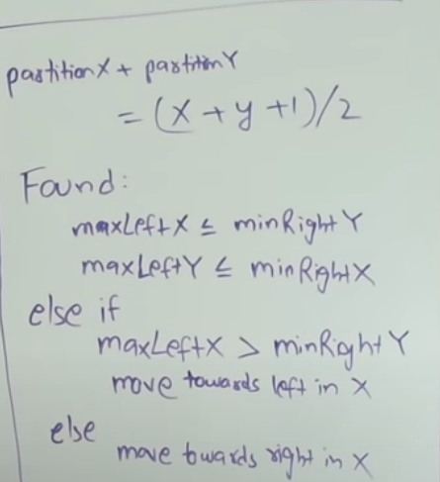

In (x+y+1)/2, **“+1”** is done because it works good with both odd and even value of (x+y).

## Example 1:

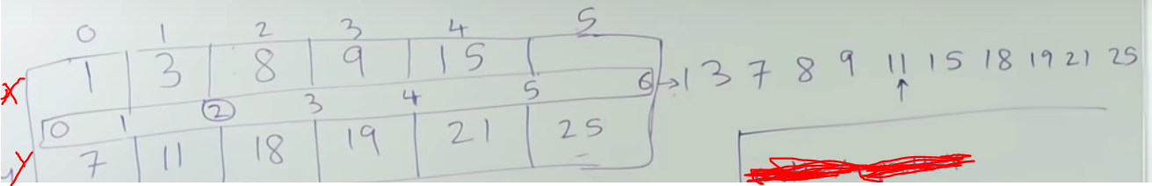

We will perform binary search on the smaller array.

**Start = 0**

**End = len (X) – 1**

**positionX = (start + end)/2**

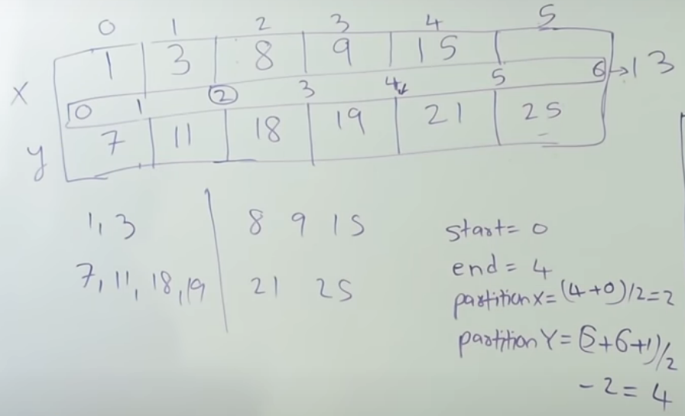

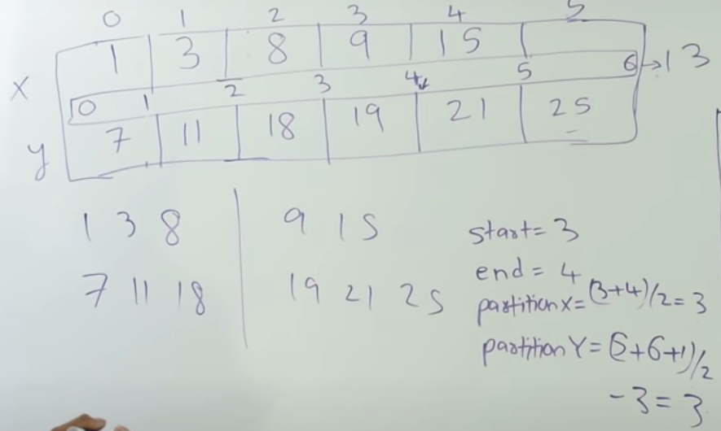

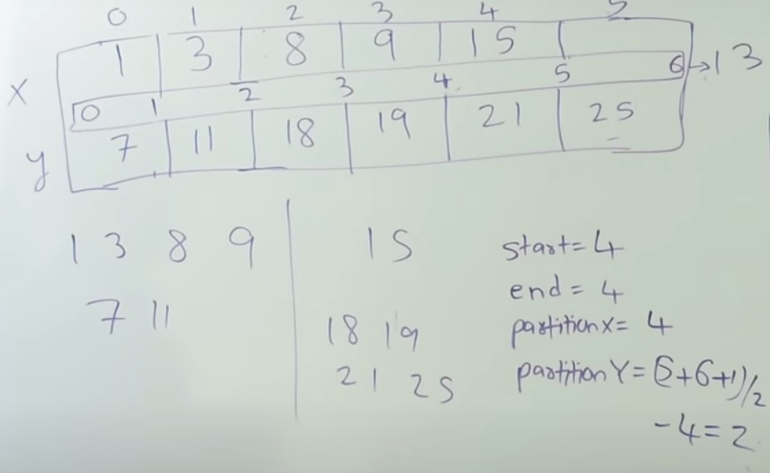

Hence soln = max(9, 11) = 11

## Example 2 (demonstrating an edge case):

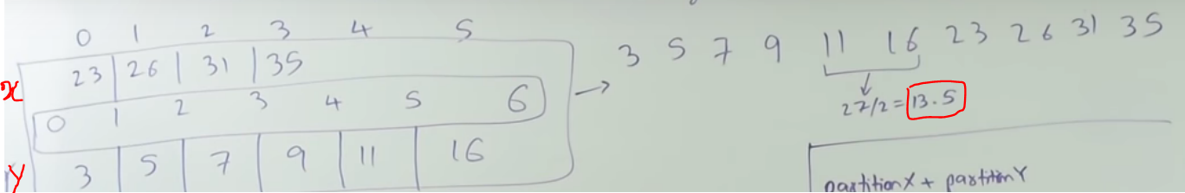

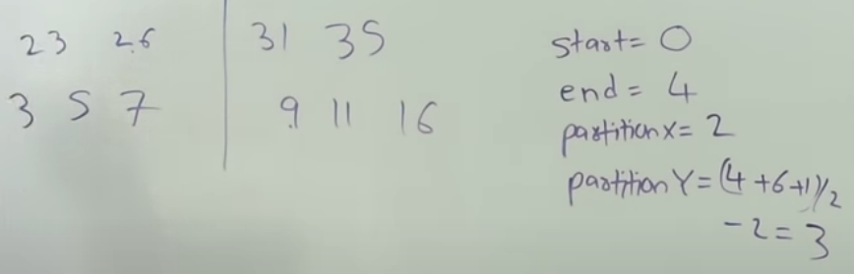

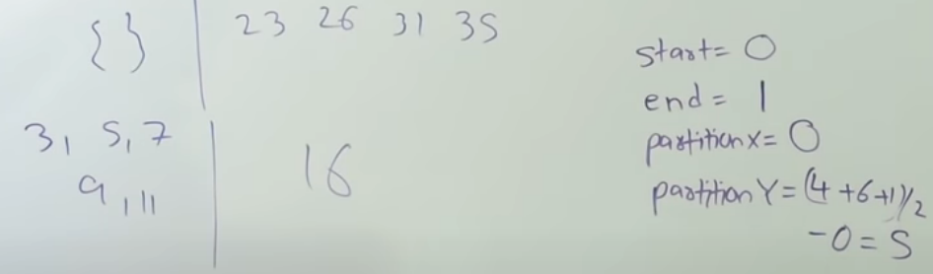

In such case take the empty element as **–INF** and solve the question.

Similarly on getting empty array on right hand side, use **+INF**.

